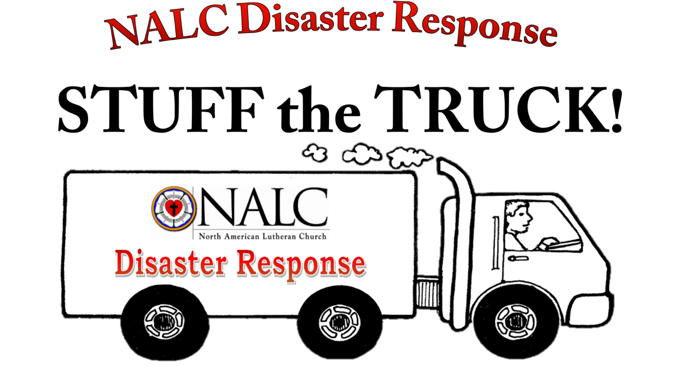
Please bring your prayers and support to:

Suggested Donations^{J}
- Bibles
- Quilts & Blankets
- Flood Buckets
- School Kits
- Healthcare Kits
- Gift Cards
Monetary Donations
Financial donations designated for
NALC Disaster Response*
should be made payable and mailed to:
North American Lutheran Church
PO BOX 860565
Minneapolis, MN 55486-0565
*Please indicate “NALC Disaster Response” on the memo line of your check

For more information contact:
Mary Bates, NALC Disaster Response
740-509-1132 -or-
disasterresponse@thenalc.or

